**IT Network Solutions**

**IT Security**

Network security firewall

Network security software

CCTV solutions

**Network Security Firewall**

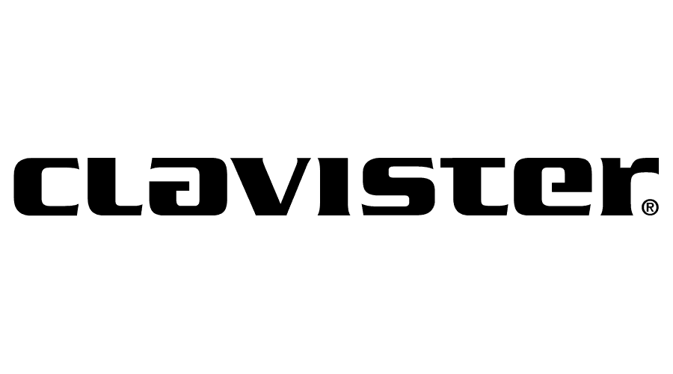 Our Partners – (white color)

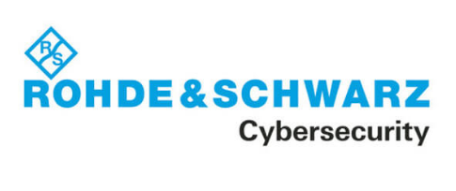

**NetGate Pfsense Firewall**

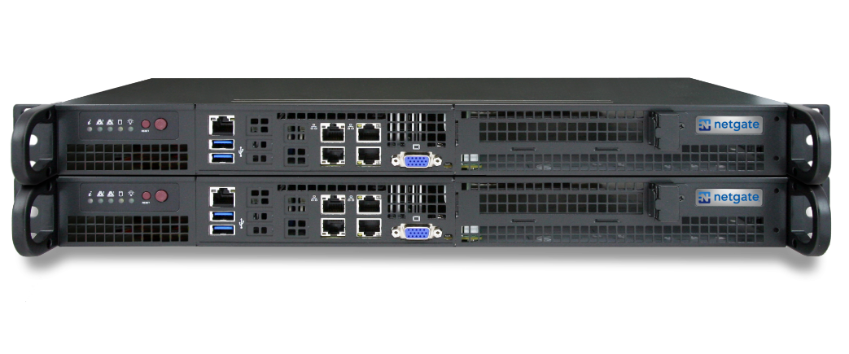The world’s most popular, feature-rich and robust firewall, router and VPN solutions. Ideal for personal users, professional users, and organizations looking for easy-to-use, powerful, flexible, proven solutions for safely connecting to the Internet.

PfSense Plus software is a powerful firewall, router and VPN solution that leverages a number of highly regarded open-source projects. The software competes effectively with far more expensive, commercial alternatives and is used by hundreds of thousands of businesses, educational institutions, and government agencies all over the world. Leading secure-networking features and capabilities include:

* 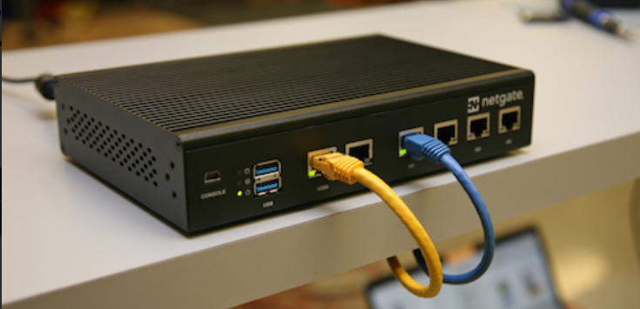Ad blocker (pfBlockerNG)
* Captive portal
* CARP / HA
* DNS server
* DHCP server
* IP / Country block list (pfBlocker)
* IDS/IPS
* Packet capture / inspection
* Port forwarding
* QOS / rate limiters
* Software load balancer (HA Proxy)
* Traffic monitoring
* Traffic logging, statistics, and graphs
* Traffic shaping
* VLAN
* Wake-on-LAN
* Website blocker (pfBlocker)
* HTTP transparent / web / reverse proxy (Squid)

Learn more about the power of pfSense Plus software [here](https://docs.netgate.com/). <http://www.netgate.com>

https://www.lancom-systems.com

Rohde and Schwarz / Lancom network security

## **Cybersecurity "made in Germany"**

The LANCOM R&S®Unified Firewalls offer industry-leading network security through state-of-the-art Unified Threat Management (UTM). With an intuitive graphical Web interface, they impress with disruptive usability, minimizing potential sources of error during firewall configuration. In addition, the “One-Click Security” concept of the LANCOM Management Cloud enables the automated implementation of precisely tailored security architectures with firewalls at geographically distributed locations. The next-generation UTM firewalls developed in Germany stand for trustworthy corporate networks and guaranteed freedom from backdoors

* IT security through UTM “Made in Germany” and guaranteed freedom from backdoors
* Top usability with intuitive Web interface and convenient setup wizards
* Automated configuration with One-Click Security and SD-Branch via the LANCOM Management Cloud
* Protection against spam, viruses, malware, and cyberattacks
* Preventive security against as yet unknown threats through integrated Sandboxing and Machine Learning
* State-of-the-art security techniques such as R&S®PACE2 Deep Packet Inspection and SSL Inspection
* Also available as a virtual, software-based firewall (LANCOM vFirewall)
* Custom application and filter rules for increased security via Application Management and Content Filters
* Operation in a high-availability cluster (HA cluster) possible without additional costs or licenses
* Runtime-based licensing model (1, 3, or 5 years)

|  |  |  |
| --- | --- | --- |
| [Desktop Unified Firewalls](https://www.lancom-systems.com/products/security/desktop-unified-firewalls) Next-generation UTM firewalls for industry-leading network security in small and medium enterprises | [Rack Unified Firewalls](https://www.lancom-systems.com/products/security/rack-unified-firewalls) Next-generation UTM firewalls for maximum network security in large enterprise and school networks | [Virtual Unified Firewalls](https://www.lancom-systems.com/products/security/virtual-unified-firewalls) Software-based next-generation UTM firewall in virtual hypervisor environments for highest network security |

## **Network security for small & medium enterprises (SME)**

Cyber attacks no longer stop at smaller companies and medium-sized businesses. Whether it's small or home offices, medical practices, or law firms: multi-layered, trusted protection against threats of all kinds is essential, even for smaller networks. Stay one step ahead of threats with the desktop models of the next-generation firewalls (NGFW) including Unified Threat Management (UTM) and the "One-Click Security" concept in combination with the LANCOM Management Cloud – and all this in an uncomplicated, budget-friendly way, tailored to your requirements. All LANCOM R&S®Unified Firewalls are developed in Germany and guarantee freedom from backdoors.

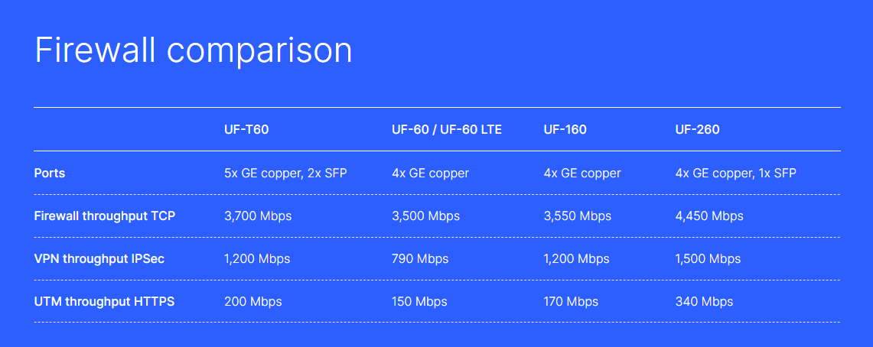

## **Network security for large enterprises and schools**

Phishing, advanced persistent threats, DDoS attacks... The threat situation for companies is getting more serious every day. Especially growing, distributed enterprises with demanding networks and high data volumes need powerful security technologies. With the rack models of the next-generation firewalls (NGFW) and Unified Threat Management (UTM), you rely on a holistic security solution. With the "One-Click Security" concept of the LANCOM Manage­ment Cloud, precisely tailored security architectures are implemented in an automated, transparent, and uncomplicated manner. All LANCOM R&S®Unified Firewalls are developed in Germany and guarantee freedom from backdoors.

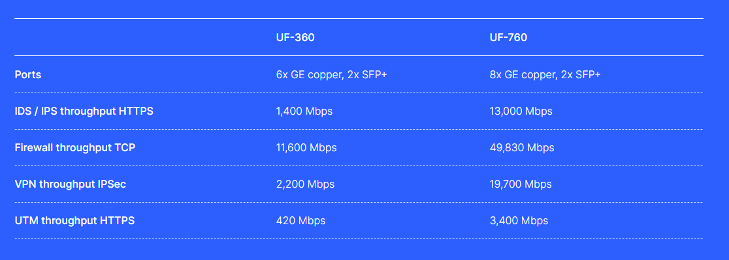

**Products**

## **Virtual firewall with UTM for next-generation security**

Intelligent, consistent network security is no longer something to wish for, despite maximum flexibility and low operating and maintenance costs at the same time: Operated in cloud scenarios or conventional networks, the next-generation firewall (NGFW) LANCOM vFirewall offers the same security and functionality as the hardware-based LANCOM R&S®Unified Firewalls. It has no conventional hardware to take up space. The LANCOM vFirewall simply operates in a virtualized environment based on a hypervisor such as VMware ESXi, Oracle VirtualBox, Microsoft Hyper-V, or KVM. The flexible licensing model allows your virtual firewall to "grow" with your needs in terms of UTM performance and network size.

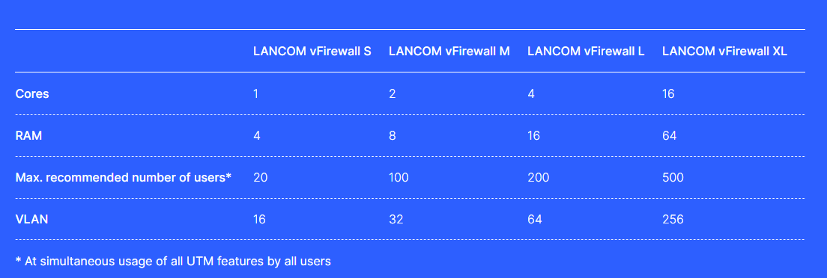

## **Clavister NetWall – the most secure NGFW**

Hackers, viruses, ransomware, data theft, industrial espionage and even government sponsored attacks. The list of cyber threats that could put your business at risk goes on and on. Add to this all the new types of technologies such as the Cloud, BYOD, WiFi and other that is supposed to make your company more productive

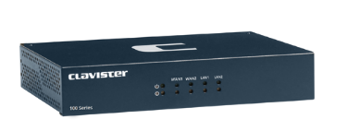

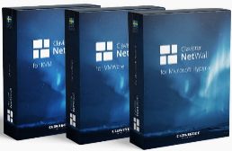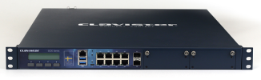

Desktop Models

Compact, fast and extremely powerful, these appliances deliver security performance for remote offices or as CPEs

<https://www.clavister.com/products/ngfw/netwall-desktop-models/>

Rack-mounted Models

For the larger enterprise users, these appliances give best in class protection for even the biggest companies

<https://www.clavister.com/products/ngfw/netwall-rack-mounted-models/>

Virtual Models

Clavister has been a pioneer in virtual products since 2008. Find out how virtual NGFWs might be the answer for your needs.

<https://www.clavister.com/products/ngfw/netwall-virtual-models/>

Security Subscriptions

Clavister’s services and knowledge products help you realize the full potential of your newly secured network.

<https://www.clavister.com/products/ngfw/ngfw-subscriptions/>

CCTV Solution

LARGE AND SMALL COMMERCIAL INSTALLATIONS

EXPERIENCED WITH INSTALLATION AND MAINTENANCE OF BOTH LARGE AND SMALL CCTV SYSTEMS.

Email Call

--------------------------------------------------------------------------------------------------------------

Weather proof WIFI CCTV SURVEILLANCE SOLUTIONS

Email Call

--------------------------------------------------------------------------------------------------------------

CCTV INSTALLATION SERVICES

Protecting your property when you are not there.

Email Call

--------------------------------------------------------------------------------------------------------------

Remote CCTV monitoring with Man power solution

Cyrus IT provides 24/7 Remote CCTV Monitoring of systems nationwide from our state of the art operations center in Colombo Srilanka.

Email Call

--------------------------------------------------------------------------------------------------------------

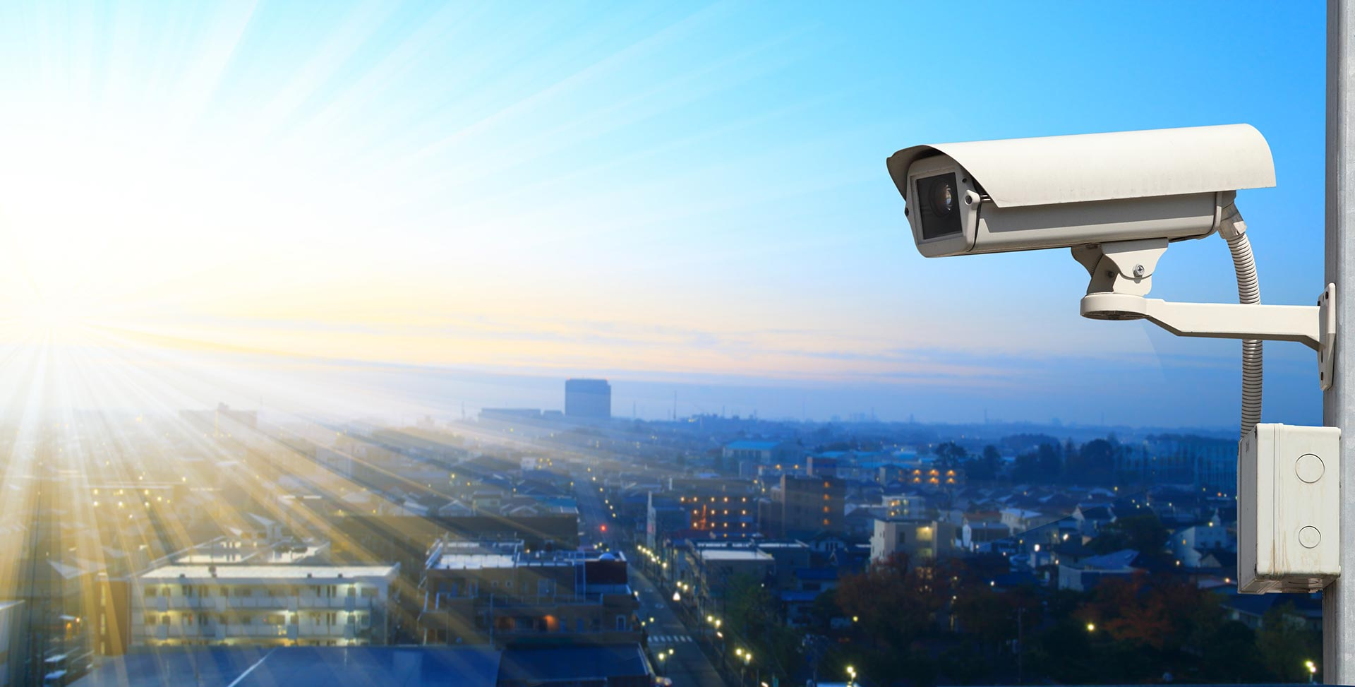

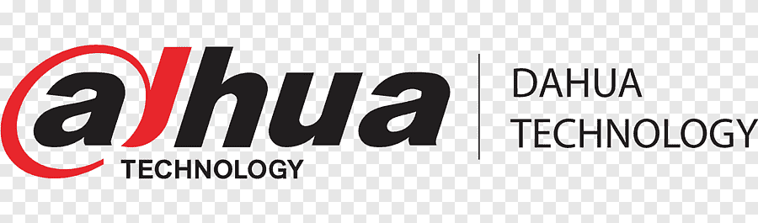

Dahua Technology https://us.dahuasecurity.com

Zhejiang Dahua Technology Co., Ltd. is a world-leading video-centric smart IoT solution and service provider. Based on technological innovations, Dahua Technology offers end-to-end security solutions, systems, and services to create values for city operations, corporate management, and consumers.

Check Dahua Products list

<https://us.dahuasecurity.com/product-selector/camera-selector/>

Check Dahua All product line up.

<https://www.dahuasecurity.com/products>

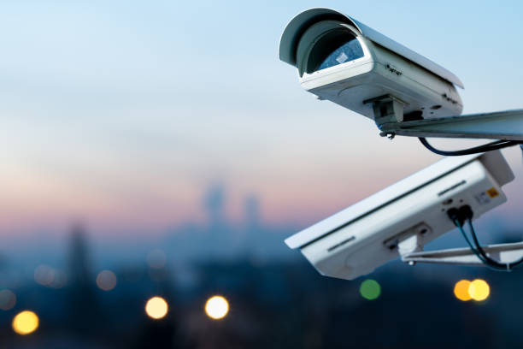

**Hik Vision**

Hikvision is the world’s largest supplier of video surveillance products and solutions. The company specializes in video surveillance technology, as well as designing and manufacturing a full-line of innovative CCTV and video surveillance products.

View all Hikvision products

<https://www.hikvision.com/en/products/>

Contact